Chapter 7, Problem 52.

Using Fig. 7.118, design a problem to help other students better understand the step response of an RL circuit.
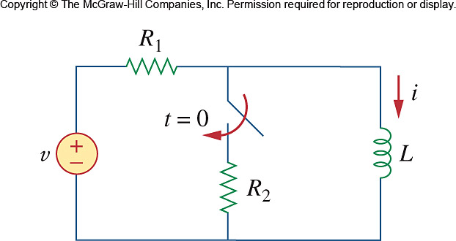

Figure 7.118
For Prob. 7.52.

